**REPORT**

인하대학교

12171708

조승효

1. Implementation Neural Network

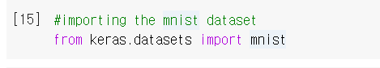

Import data set

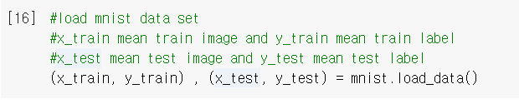

load data set into (x_train,y_train) and (x_test,y_test)

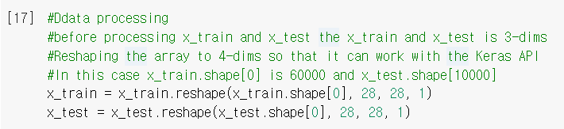

Reshape data set for using keras api

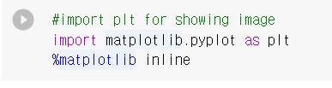

Import plt

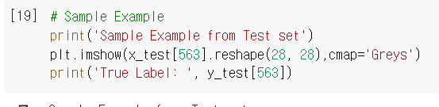

Sample image shows and the result is below

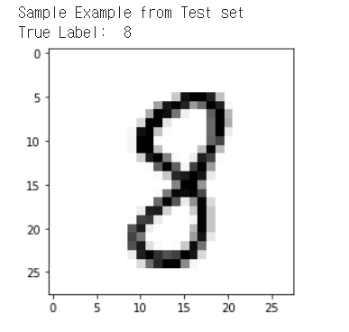

X_train and x_test have pixel information, so we can draw some picture using these. And y_train and y_test have label.

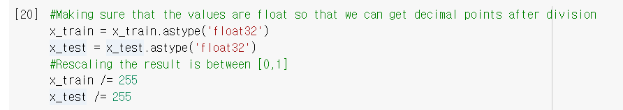

Before data processing X_train and x_test have value between 0 and 255. After data processing X_train and x_test have value between 0 and 1

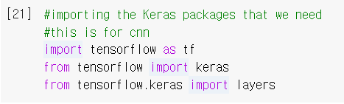

Import tensorflow

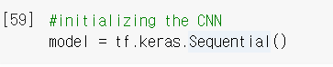

Initializing model

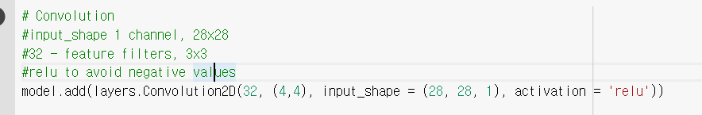

Convolution step

If the image is computed in a dense network, it will take a long time due to the large amount of computation.

This problem can be resolve by using convolution neural network.

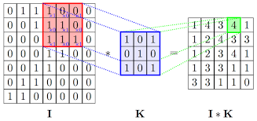

Convolution is like above. Convolution mean matrix product. I is image and K is filter. I*K is the result after convolution. If image size is 28*28 and filter size is 4*4. Filter. When the top left is (0,0)

The filter performs matrix calculations by going from 0 to 24 in the x coordinate and 0 to 24 in the y coordinate. And the result size is 25 * 25. This process will shrink the image. So we need convolution because of large amount of computation

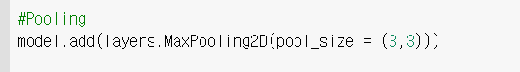

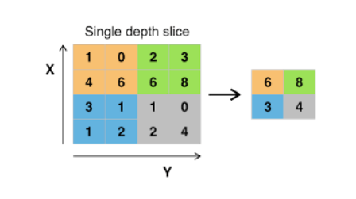

Max pooling is above. See the green part, the maximum value is 8 so the result is 8. Like this, max pooling extracts the maximum value from a specific part.

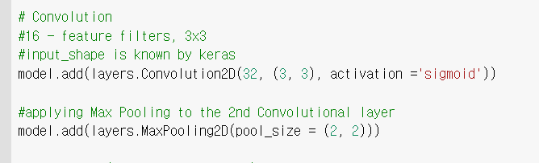

Add new layer to improve accuracy

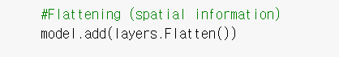

Flattening information.

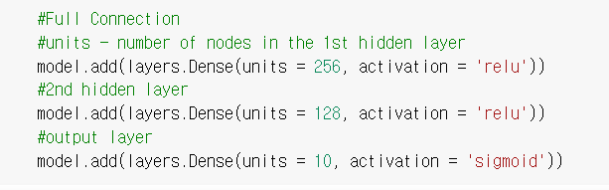

Full connection to get output.

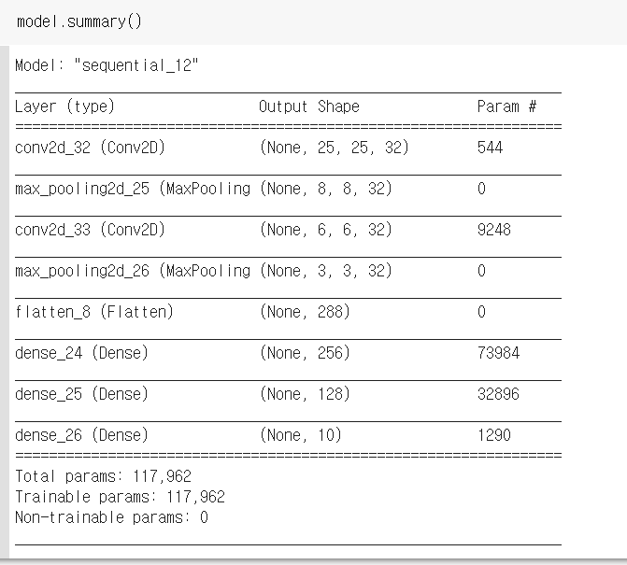

Input size is 28 * 28. After first convolution the size is 25*25, and after max_pooling the size is 8*8. And second convolution the size is 6*6 and after second max_pooling the size is 3*3 you can see the size shrink during the process. That mean the number of computation is low.

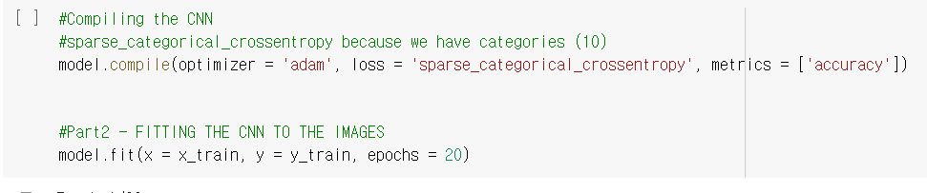

Model compile and run using traing data.

As the steps progress, you can see that the accuracy increases.

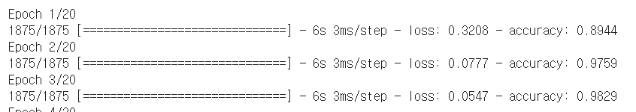

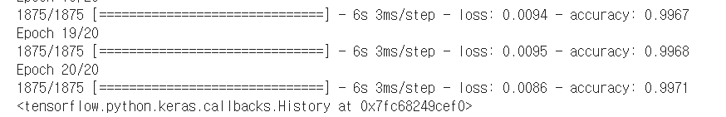

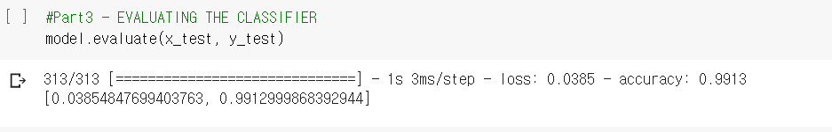

Evaluate the model using test data. The accuracy is 99%

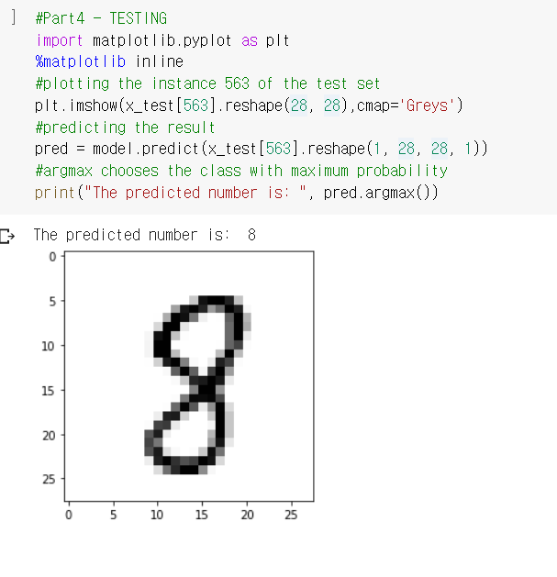

Testing some data. And the result is correct

2. Discussion

Convolutional Neural Networks is a class of deep neural networks, most commonly applied to analyzing visual imagery.

Here, CNN is used to recognize numbers.

You can see that the matrix becomes smaller as the process progresses.

If we had not used convolution and maxpooling, the computation would have been quite large.

But we used these, so the computations were significantly reduced.

As the stage progresses, the accuracy increases. However, if it rises above a certain level, it is meaningless that the stage progresses.

After convolution and maxpooling, full connection step is needed. Full connection step using activation function which simulate neuron system in human brain.

Using different activation functions gives different results

3.Reference

<https://blog.francium.tech/machine-learning-convolution-for-image-processing-42623c8dbec0>